**Parallelogram Pattern**

#### Write a program to print parallelogram pattern for the given N number of rows.

##### **For N = 4**

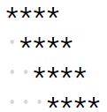

#### The dots represent spaces.

##### **Input Format :**

A single integer : N

##### **Output Format :**

Required Pattern

##### **Constraints :**

0 <= N <= 50

##### **Sample Input 1 :**

3

##### **Sample Output 1 :**

***

***

***

##### **Sample Input 2 :**

5

##### **Sample Output 2 :**

*****

*****

*****

*****

*****